SIMATS ENGINEERING
ASSESSMENT TOOL 3

COURSE NAME: Artificial Intelligence COURSE CODE: CSA1703

COURSE OUTCOME COVERED

CO2: Experiment search and game-solving techniques such as Greedy Search, A*, CSP, Minimax, and Alpha-Beta pruning with heuristic functions for solving complex AI problems efficiently. (BL3)

Assessment Tool Weightage: 40%

Duration: 1 Hour
QUESTIONS: 3 Total Marks:30

Annexure A

Dry Run Evaluation

Code of Conduct:

I sandhiya R (192511132)(Name / Reg No) certify that this submission is my original work and that I have adhered to the guidelines specified for this assessment.
I understand that any violation of academic integrity rules will result in disciplinary action.

Signature of the student: Sandhiya R

Annexure A

Dry Run Evaluation
1. Question 1 – Breadth-First Search (BFS)
Consider the following graph: A
/ \
B C
/ \ / \
D E F G
Task: Starting from node A, perform a Breadth-First Search (BFS). Complete the following table.
Iteration | Queue | Visited Node
1
2
3
4
5
6
7
Questions:
- Write the BFS traversal order.
- Show the queue contents after each iteration.
Answer:
from collections import deque

# Graph Representation
graph = {
'A': ['B', 'C'],
'B': ['D', 'E'],
'C': ['F', 'G'],
'D': [],
'E': [],
'F': [],
'G': []
}

visited = []
queue = deque()

start = 'A'
queue.append(start)
visited.append(start)

print("Iteration\tQueue Before\tVisited Node\tQueue After")

iteration = 1

while queue:

queue_before = list(queue)

node = queue.popleft()

for neighbour in graph[node]:
if neighbour not in visited:
visited.append(neighbour)
queue.append(neighbour)

queue_after = list(queue)

print(iteration, "\t\t", queue_before, "\t", node, "\t\t", queue_after)

iteration += 1

print("\nBFS Traversal:", " -> ".join(visited))
Output
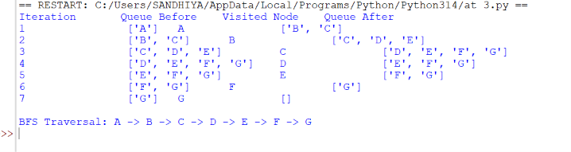
1. Write the BFS Traversal Order.
Answer:
A → B → C → D → E → F → G
2. Show the Queue Contents After Each Iteration.
Iteration | Queue After
1 | B, C
2 | C, D, E
3 | D, E, F, G
4 | E, F, G
5 | F, G
6 | G
7 | Empty

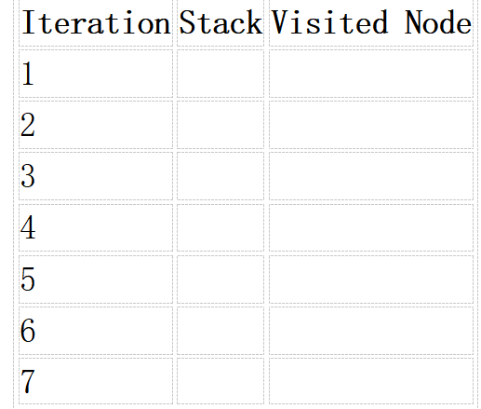
2. Depth-First Search (DFS) Using the same graph,
A
/ \
B C
/ \ / \
D E F G
Perform Depth-First Search (DFS) starting from A.
Complete the table.
Answer:
# Depth-First Search (DFS)

graph = {
'A': ['B', 'C'],
'B': ['D', 'E'],
'C': ['F', 'G'],
'D': [],
'E': [],
'F': [],
'G': []
}

visited = []
stack = []

start = 'A'
stack.append(start)

print("Iteration\tStack Before\tVisited Node\tStack After")

iteration = 1

while stack:

stack_before = list(stack)

node = stack.pop()

if node not in visited:
visited.append(node)

# Push adjacent nodes in reverse order
for neighbour in reversed(graph[node]):
if neighbour not in visited:
stack.append(neighbour)

stack_after = list(stack)

print(iteration, "\t\t", stack_before, "\t", node, "\t\t", stack_after)

iteration += 1

print("\nDFS Traversal:", " -> ".join(visited))
Output
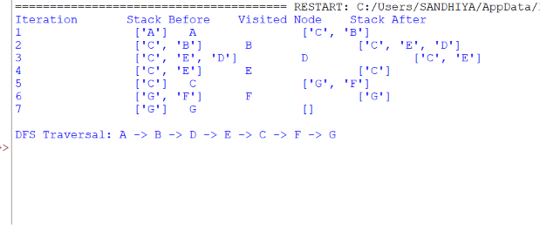
1. Write the DFS Traversal Order.
Answer:
A → B → D → E → C → F → G

2. Show the Stack Contents After Each Iteration.
Iteration | Stack After
1 | C, B
2 | C, E, D
3 | C, E
4 | C
5 | G, F
6 | G
7 | Empty

- Initial State :
1 3 6
5 0 2
4 7 8

Goal State :
1 2 3
4 5 6
7 8 0

Task
Trace Breadth-First Search (BFS) until the goal state is reached.
Fill in the table.
Iteration | Current State | Queue Before Expansion | Queue After Expansion
1
2
3
4
5

Questions
- Which node is expanded in each iteration?
- How many states are generated in total?
- Write the complete solution path from the initial state to the goal state.
- Why does BFS always find the shortest solution in an unweighted 8-puzzle problem?
Answer:
from collections import deque

# Goal State
goal = (1, 2, 3,
4, 5, 6,
7, 8, 0)

# Initial State
start = (1, 3, 6,
5, 0, 2,
4, 7, 8)

# Possible moves for blank tile
moves = {
0: [1, 3],
1: [0, 2, 4],
2: [1, 5],
3: [0, 4, 6],
4: [1, 3, 5, 7],
5: [2, 4, 8],
6: [3, 7],
7: [4, 6, 8],
8: [5, 7]
}

def get_neighbors(state):
zero = state.index(0)
neighbors = []

for move in moves[zero]:
new_state = list(state)
new_state[zero], new_state[move] = new_state[move], new_state[zero]
neighbors.append(tuple(new_state))

return neighbors

queue = deque([(start, [start])])
visited = set()

iteration = 1

while queue:

current, path = queue.popleft()

if current in visited:
continue

visited.add(current)

print("\nIteration", iteration)

for i in range(0, 9, 3):
print(current[i:i+3])

if current == goal:

print("\nGoal State Reached!")

print("\nSolution Path")

for step in path:
print()

for i in range(0, 9, 3):
print(step[i:i+3])

print("\nTotal States Generated =", len(visited))
break

for neighbor in get_neighbors(current):
if neighbor not in visited:
queue.append((neighbor, path + [neighbor]))

iteration += 1
Output
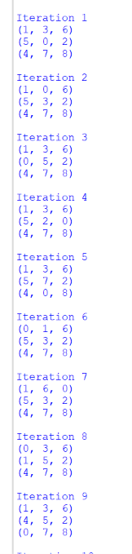
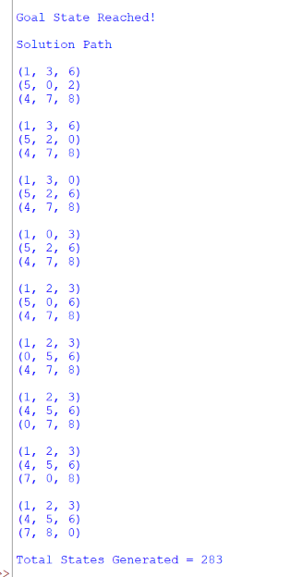
1. Which node is expanded in each iteration?
Answer:
- In each iteration, the front node (first state) in the queue is expanded.
- BFS expands nodes level by level, ensuring that all states at the current depth are explored before moving to the next depth.
2. How many states are generated in total?
Answer:
- The total number of generated states depends on the puzzle configuration.
- It is equal to the number of unique states visited before reaching the goal.
- In the program, this is displayed as:
print("Total States Generated =", len(visited))
3. Write the complete solution path from the initial state to the goal state.
Answer:
- The solution path consists of all puzzle states from the initial state to the goal state.
- BFS guarantees that this path is the shortest sequence of moves.
- The program prints the complete path after reaching the goal state.
4. Why does BFS always find the shortest solution in an unweighted 8-puzzle problem?
Answer:
- BFS explores all states level by level.
- Each move in the 8-puzzle has the same cost (one move).
- Therefore, the first time the goal state is reached, it is through the minimum number of moves.
- Hence, BFS always finds the shortest solution in an unweighted 8-puzzle.
RUBRICS FOR CALCULATION

Criteria | Weightage (%) | Level 4 – Exemplary (4) | Level 3 – Proficient (3) | Level 2 – Developing (2) | Level 1 – Beginning (1)
Understanding of Search Problem | 20 | Clearly understands the search problem, initial state, goal state, and search strategy. | Understands the problem with minor misunderstandings. | Demonstrates partial understanding of the search problem. | Shows little or no understanding of the search problem.
State Expansion and Dry Run Execution | 30 | Correctly traces every iteration, expands nodes accurately, and maintains the Queue/Stack/Priority Queue without errors. | Performs most iterations correctly with minor mistakes in state expansion or data structure updates. | Performs only some iterations correctly; several errors in tracing or node expansion. | Unable to correctly perform the dry run or expand states.
Application of Search Algorithm | 20 | Applies the selected algorithm (BFS/DFS/UCS) correctly, following all algorithmic rules. | Applies the algorithm correctly with a few procedural errors. | Applies only basic algorithm steps with noticeable mistakes. | Fails to apply the correct search algorithm.
Accuracy of Solution Path | 20 | Identifies the correct traversal order/solution path and goal state with proper justification. | Solution path is mostly correct with minor errors. | Partially correct solution path; goal may not be reached correctly. | Incorrect or incomplete solution path.
Presentation and Logical Reasoning | 10 | Queue/Stack/Priority Queue updates, state diagrams, and explanations are neat, organized, and logically presented. | Presentation is clear with minor organizational issues. | Limited explanation and organization; reasoning is partially clear. | Poor presentation with unclear or missing reasoning.

